John Villalona

EMT 2390L

Class work #1

Creating a bash script

Step #1: create the bash script on the terminal by typing sudo nano clean_up.sh and save it.

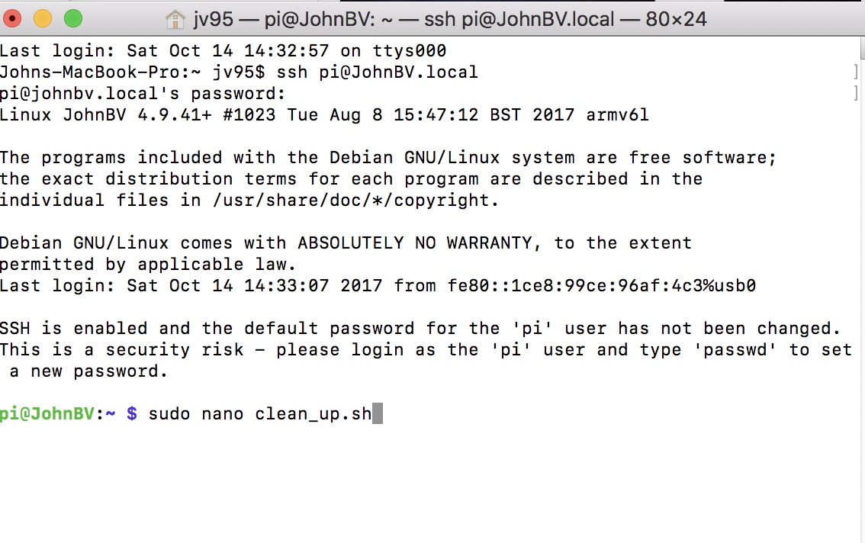

Step #2: Then it will o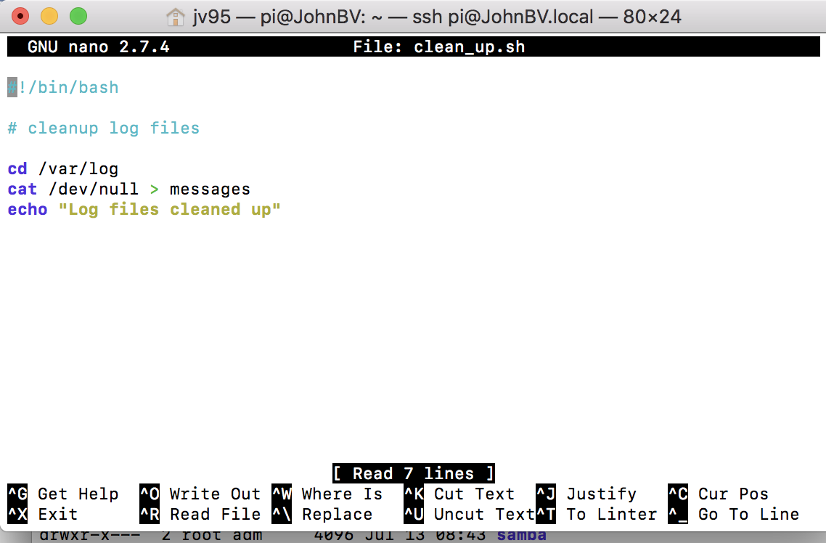pen the nano where you must type and save the code below

Step 3: Type cd /var /log to change the directory of the file after sudo nano clean_up.sh is save and executed as shown below.

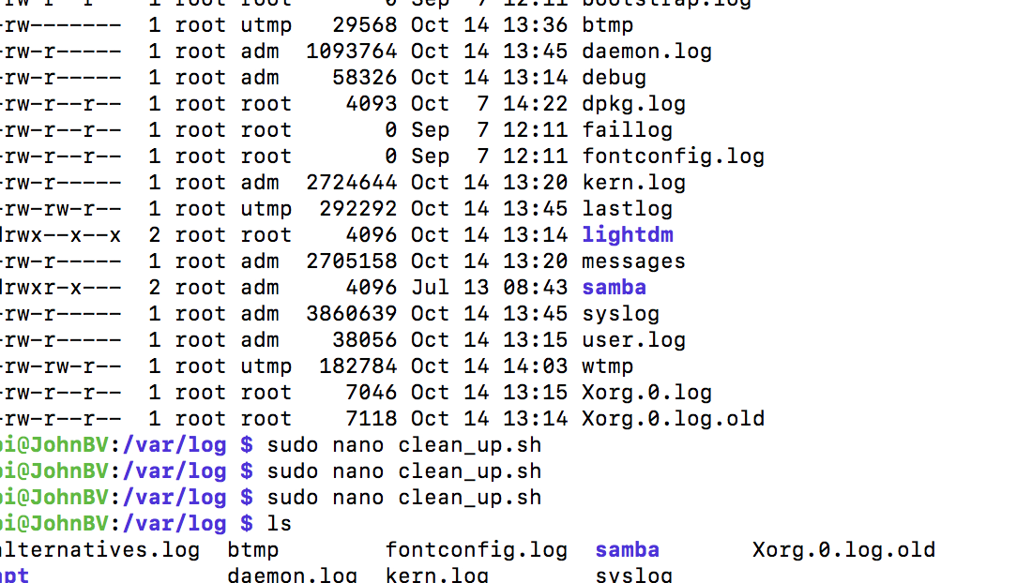

4) This will allow you to see all the directories in the file as shown below

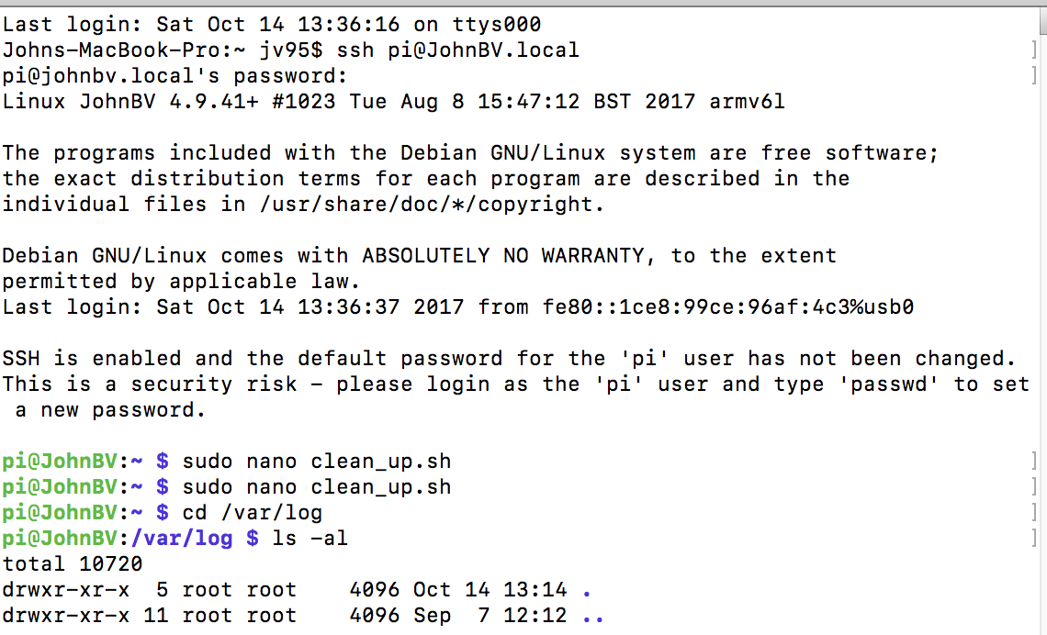

5)Finally type sudo nano clean_up.sh to clean up the messages file that has 27,05158 kb as shown above and once hit enter it reduce to zero according to photo below. Also, ls is in the picture ls is shown so the student can see the list of files in the directory.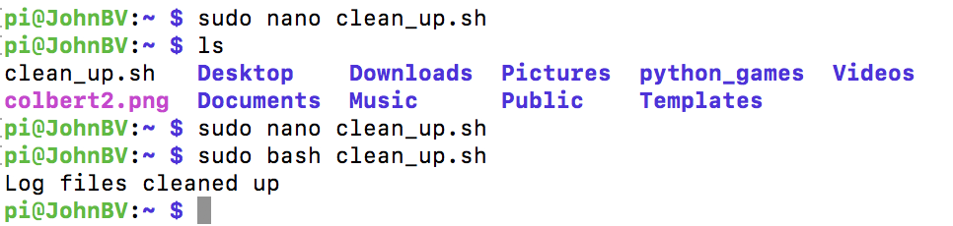

6) Once done with the assignment the student has to complete the GitHub tutorial as shown below.

